**TOPIC 6 COMPUTER NETWORKS**

* **Definition of a network and its main characteristics**

Network - is a group of two or more computers or other electronic devices that are interconnected for the purpose of exchanging data and sharing resources.

These following types of **network characteristics** also used to categorize the types of network.

***Network topology***: Network topology is the geometric arrangement of computer systems. In practically highly used topology are Bus topology, Star topology, Ring topology, mesh topology etc.

***Network Protocol***: A Network protocol defines a common set of rules and signals for computer systems on the network use to communication. Highly preferred network protocol in real time environment is LAN, sometimes called Ethernet. Another popular LAN protocol for personal computers is the IBM token-ring network.

***Network Architecture*:** Network architecture can be broadly classified as using either a peer-to-peer or client/server architecture.

* **Classification of networks based on size and scope**

There are different network types that depend on how large they are and how much of an area they cover geographically, for example:

**PAN** (personal area network). It is the type of network that is used on a personal level.

**LAN** (local area network). A local area network is a group of devices such as computers, servers, printers which are located in the same building.

**MAN** (metropolitan area network). A network that spans over several buildings in a city or town and is connected using a high-speed connection such as fiber optic cable.

**WAN** (wide area network). It is a network that spans over a large geographical area such as a country continent or even the entire globe.

* **Communication channels and their main types**

A **communication channel** is the medium used to transport information fron one network device to another. Data transmitted over a communication channel usually takes the form of an electromagnetic signal- waves of light, electricity or sound. These waves can travel through the air or or through cables, so channels transport data through wires and cables including twisted pair wires used for telephone land lines, coaxial cables for cable television networks and fibre-optic cables used for high-capacity truncklines that provide main routes for telephone, cable and internet communications. Wireless channels transport data from one device to another without the use of cables and wires.

**Wired channels**

Wired networks are more difficult to install, but they are cheaper, faster and more reliable.

An example of a wired network technology is Ethernet.

**Wireless channels**

Wireless networks let you move, from one access point to another, but they are less secure and subject to interference.

These are the **main types of wireless networks**:

Satellites - for long distances;

*Wi-Fi* - for medium-range distances;

*Bluetooth* - for short distances;

*WiMAX*- for connecting WiFi hotspots

*GSM-* for mobile phones

* **Network topology, network architecture**

There are 5 main types of network topology^

**Full mesh**/ A full mesh topology connects each network device to many other network devices. Data travelling on a mesh network can take any of several possible paths from its sourse to its destination.

**Point-to-point/** When periphreals devices connect to a host device using expantion ports, usb cables or Bluetooth, these connection are the example of p2p topology

**Star/** A network arranged as a star topology features a central connection point for all workstations and peripherals. The central connection point is not nessesarily a server. More typically it is a network device called a hub.

**Bus/** A bus topology uses a common backbone functions as a shared communication link, which carries network data.

**Partial mesh/** In a partial mesh topology, some of the devices are connected to many devices together, but other devices are connected only to 1 or 2 devices.

In a client server network, a computer acts a server and stores and distributes informayion to the other nodes or clients. In a peer-to-peer network, all the computers have the same capabilities-that is , share files and peripherals without requiring a separate server computer. Client-server network – it is computer network that use a special computer to store data, manage/provide resources and control user access.

The server acts as a central point on the network to which other computers connect. A computer that connects to the server is called a client.

Peer-to-peer network – it is a network in which there are no special servers.

* **Network protocols**

**Network protocols** – it is a set of rules for efficient data transfer from one network node to another. It is a language or set of rules, that computers use to communicate with each other. Networks use different protocols. For instance, the internet uses TCP\IP. Protocols set standarts for encoding and decoding data, guiding data for its destination, and reducing the effects of interference. Networks use more than one protocol. The collection of protocols for a network is reffered to as a protocol stack.

For example:

**IRC (**Internet Relay Chat) - It transmits text messages in real time between online users.

**Transmission Control Protocol (**TCP) - It is designed to control the transmission of Internet data.

* **Cloud computing**

Cloud computing is made possible by a technology called virtualization. Virtualization allows you to create a digital-only "virtual" computer or virtual machine which behaves as if it were a physical computer. By running multiple virtual machines simultaneously, multiple virtual "servers" can run on a single server and they don’t interact with each other at all.Virtual machines also make more efficient use of the hardware hosting them. By running many virtual machines at once one server can run many virtual servers and a data center becomes like a whole host of data centers, able to serve many organisations. Even if individual servers go down, cloud servers as a whole should always be available. The purpose of the cloud computing is to keep information save not overloading a personal computer.

**2)**

1. **The Internet and the WEB:**

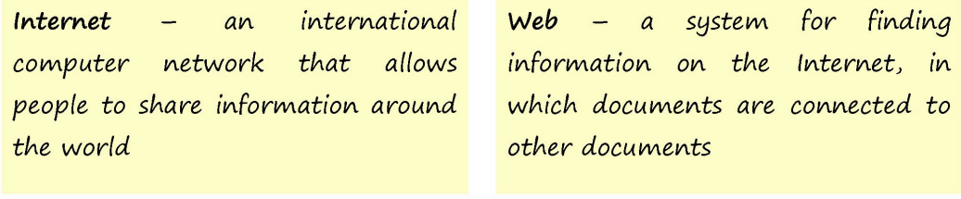

Another way to look at this difference is; *the Internet* is infrastructure while *the Web* is served on top of that infrastructure.

* There are different types of Internet connections that connect your computer to your Internet Service Provider (ISP), for examples:
* DSL (Digital Subscriber Line);
* Cable Internet access;
* Dial-Up connection is the slowest type
* Fiber internet connection the fastest type, its speed exceeds even DSL.
* Cellular connection (4G, LTE, 5G)
* World Wide Web (the Web) – it is a huge part of the Internet, which consists of the linked documents, called pages.
* There are some components and technologies of the Web, for example:
* A browser is a software that helps you look for information on the Internet.
* A website is a document on the Web giving information about a particular subject, person or institution.

1. **Types of Internet protocols:**

**1.**TRANSMISSION CONTROL PROTOCOL (TCP)

* *is one of the main protocols of the Internet protocol suite. It originated in the initial network implementation in which it complemented the Internet Protocol.*

2.INTERNET PROTOCOL (IP)

* *is the set of rules governing the format of data sent via the internet or local network. In essence, IP addresses are the identifier that allows information to be sent between devices on a network: they contain location information and make devices accessible for communication.*

3.USER DATAGRAM PROTOCOL (UDP)

* With UDP, computer applications can send messages, in this case referred to as datagrams, to other hosts on an Internet Protocol network.

4.POST OFFICE PROTOCOL (POP)

* In computing, the Post Office Protocol is an application-layer Internet standard protocol used by e-mail clients to retrieve e-mail from a mail server.

5.SIMPLE MAIL TRANSPORT PROTOCOL (SMTP)

* The Simple Mail Transfer Protocol is an internet standard communication protocol for electronic mail transmission.

6.FILE TRANSFER PROTOCOL (FTP)

* The File Transfer Protocol is a standard communication protocol used for the transfer of computer files from a server to a client on a computer network. FTP is built on a client–server model architecture using separate control and data connections between the client and the server.

7.HYPER TEXT TRANSFER PROTOCOL (HTTP)

* HTTP is the protocol used to transfer data over the web. The HTTP server is typically a web host running web server software, such as Apache or IIS.

8.HYPER TEXT TRANSFER PROTOCOL SECURE (HTTPS)

* It is used for secure communication over a computer network, and is widely used on the Internet.

1. **Technologies and components of the www**

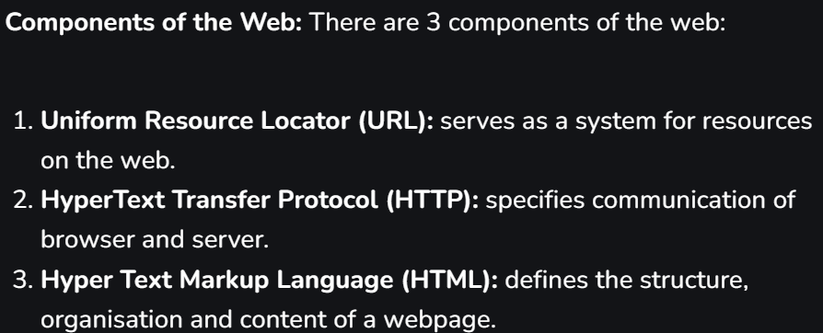

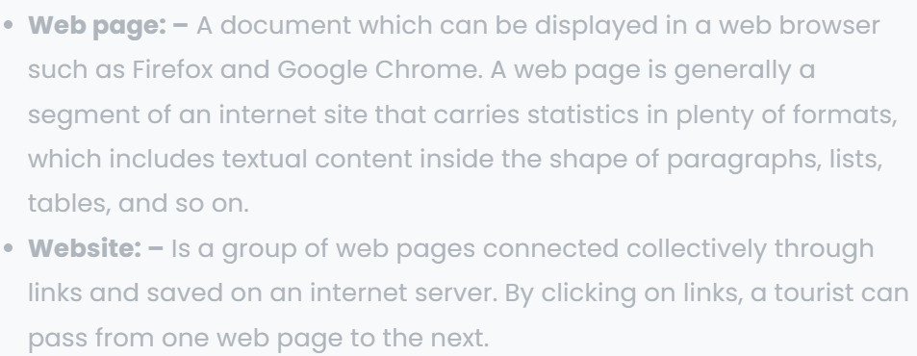

1. **Types of communication**

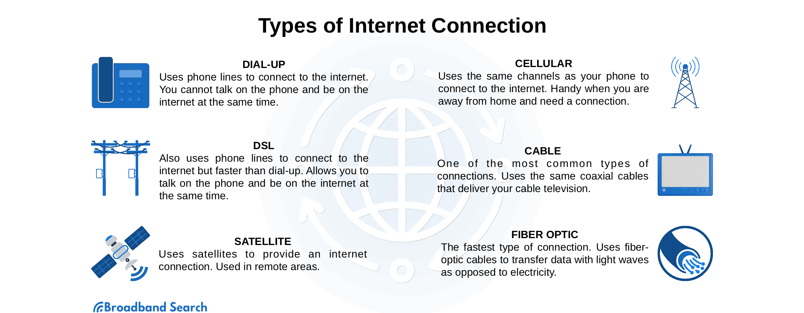

**3)** **Definition and applications of the IoT**

The Internet of Things (IoT) – it is the billions of physical devices that can communicate with the network independently of human action.

The applications of the IoT include today:

different medicine, transportation, energy production, smart home apps and others.

Some benefits that IoT brings:

− helps to save time;

− makes our life comfortable and easy;

− helps to track the state of health.

**2) IoT ecosystem**

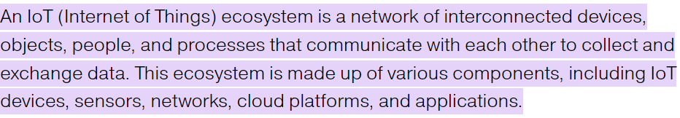

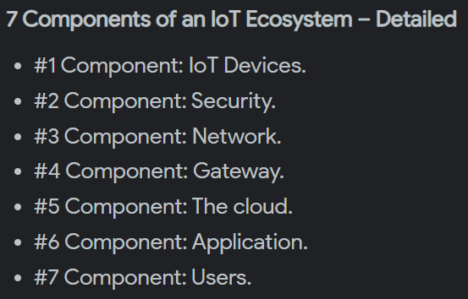

**3) Benefits that the IoT brings**

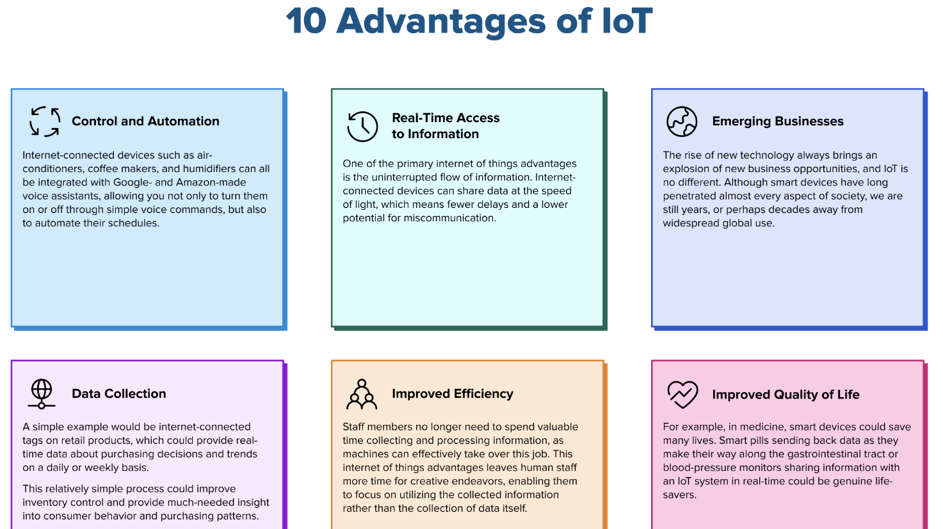

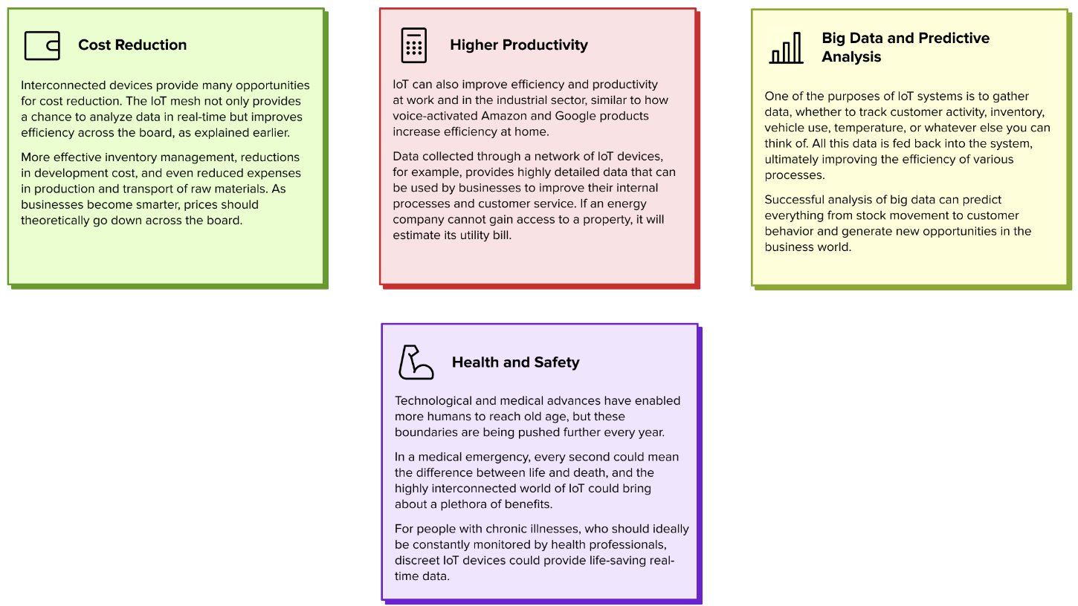

4)**Problems related to the IoT and their solutions**

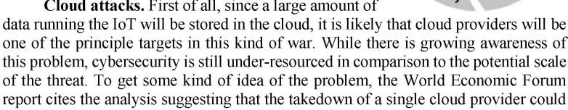

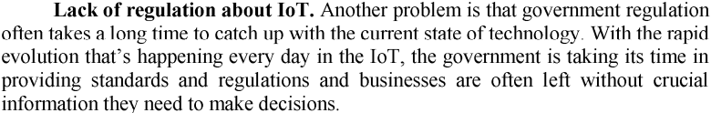

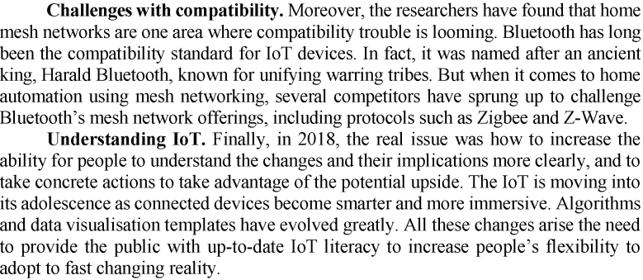

5) **Future of the IoT**

